**Experiment 3.3**

**Student Name: Sahul Kumar Parida UID: 20BCS4919**

**Branch: CSE Section/Group: WM 904/B**

**Semester: 5th Date of Performance: 02/11/22**

**Subject Name: Machine Learning Lab Subject Code: CSP-317**

**1. Aim/Overview of the practical:**

To implement Association Rule Mining.

# 2. Task to be done:

# Step 1: Import the Libraries

# Step 2: Importing the Dataset

# Step 3: Data Preprocessing

# Step 4: Applying Apriori

# Step 5: Viewing the Results

# 3. Apparatus/Simulator used:

* Jupyter Notebook/Google Collab
* Association rule mining finds interesting associations and relationships among large sets of data items. This rule shows how frequently an item set occurs in a transaction. A typical example is a Market Based Analysis.
* Market Based Analysis is one of the key techniques used by large relations to show associations between items. It allows retailers to identify relationships between the items that people buy together frequently.

**4. Code and Output:**

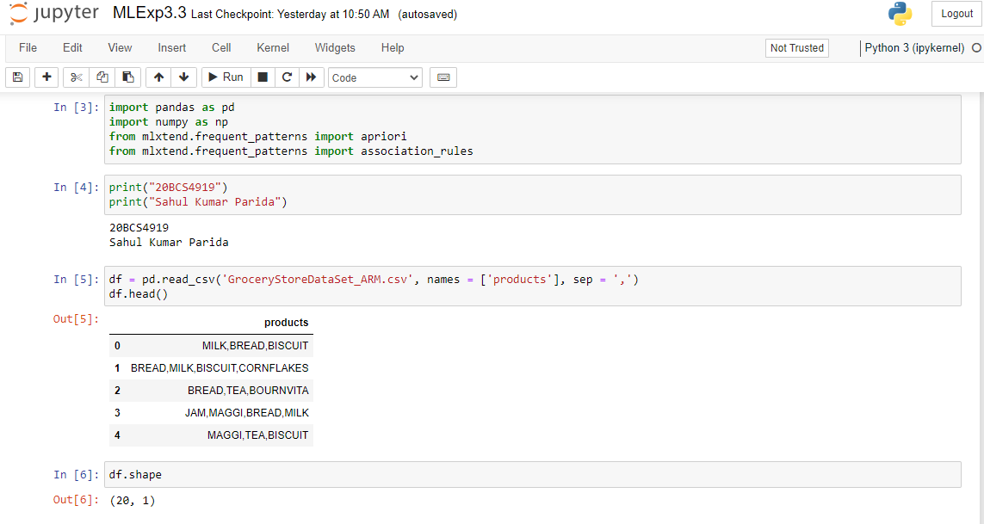

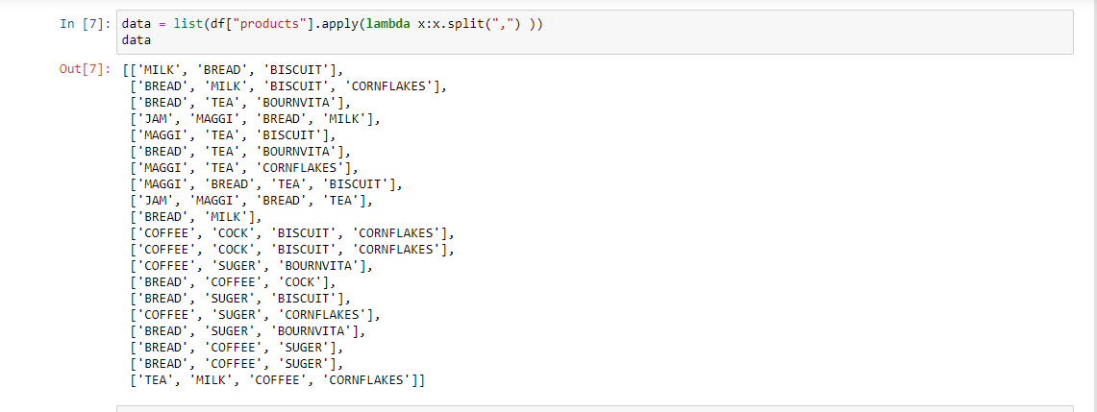

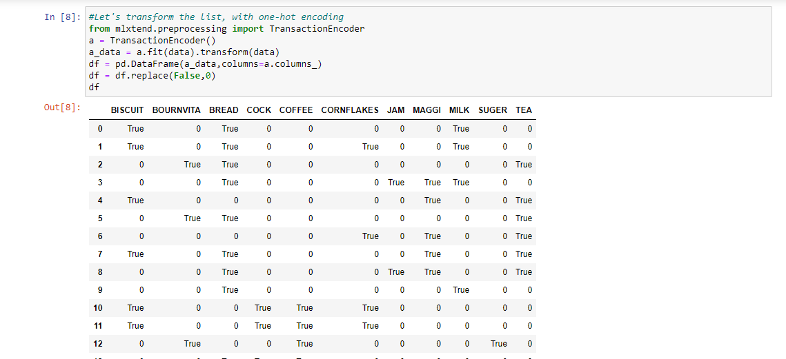

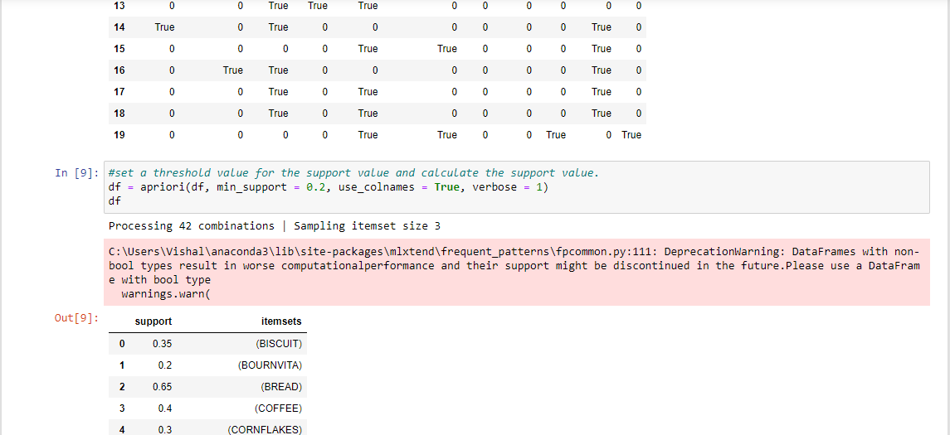

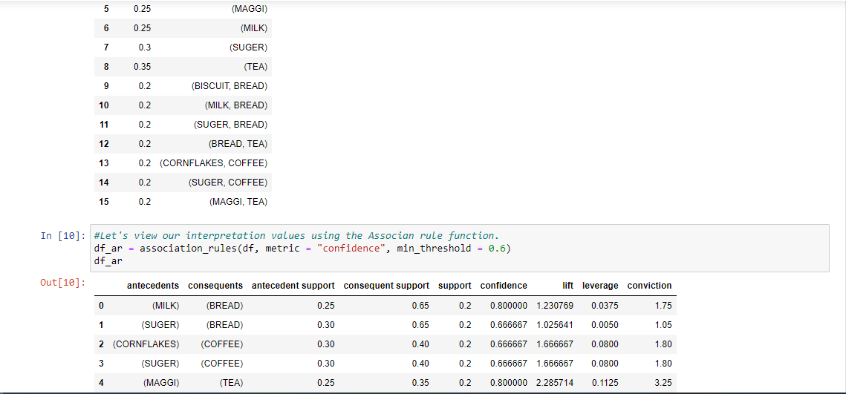

**Learning outcomes (What I have learnt):**

1. Learning about different library/packages of python.
2. Learning about the different methods, that are needed to analyze the given dataset.
3. Learning about different Machine Learning Functions.
4. We learn to split data into training and testing datasets.
5. Implementation of Association Rule Mining.